**PRACTICAL 9**

**Aim:** Implementation and analysis of Apriori Algorithm using Market Basket Analysis.

**Theory:**

Apriori Algorithm:

1. The Apriori Algorithm is an influential algorithm for mining frequent itemsets for boolean association rules.

2. Apriori uses a "bottom up" approach, where frequent subsets are extended one item at a time (a step known as candidate generation, and groups of candidates are tested against the data.

3. Apriori is designed to operate on database containing transactions (for example, collections of items bought by customers, or details of a website frequentation).

Key Concepts:

a. Frequent Itemsets: All the sets which contain the item with the minimum support (denoted by Li for ith itemset).

b. Apriori Property: Any subset of frequent itemset must be frequent.

c. Join Operation: To find Lk , a set of candidate k-itemsets is generated by joining Lk-1 with itself.

**Steps to perform Apriori Algorithm:**

Step 1 - Scan the transaction data base to get the support of S each 1-itemset, compare S with min_sup and get a support of 1-itemset, L1

Step 2 - Use Lk-1 join Lk-1 to generate a set of candidate k-itemsets. And use Apriori property to prune the unfrequented k-itemsets from this set.

Step 3 - Scan the transaction database to get the support S of each candidate k-itemset in the find set, compare S with min_sup and get a set of frequent k-itemsets Lk

Step 4 - If the candidate set=NULL then go to step 5 else go to step2 .

Step 5 - For each frequent itemset 1, generate all nonempty subsets of 1

Step 6 - For every non empty subset s of 1, output the rule “s=>(1-s)” if confidence C of the rule “s=>(1- s)” (=support s of 1/support S of s) min_conf.

Apriori Algorithm:

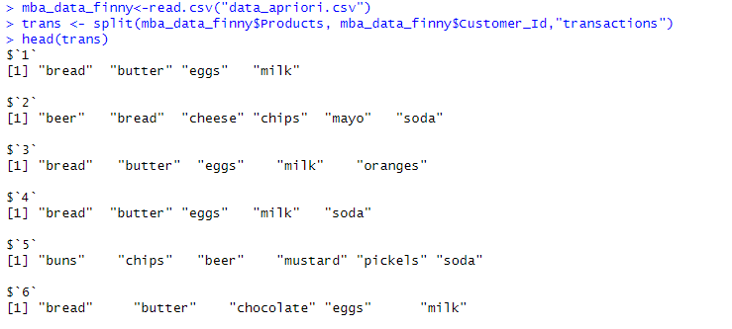

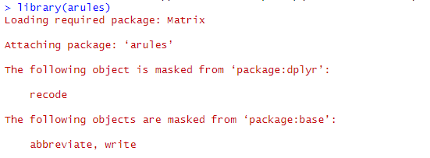

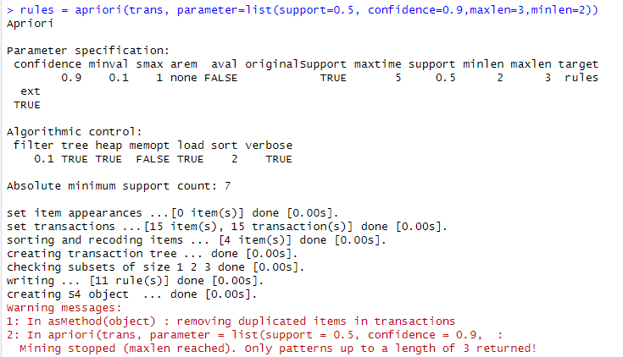

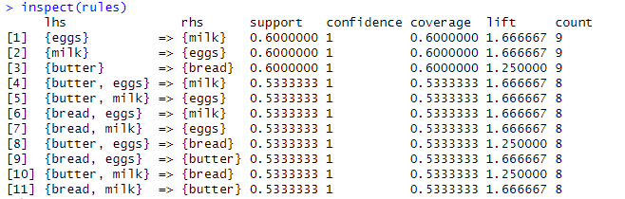

**Conclusion:** Successfully implemented Apriori algorithm in R.